**Weekly Report - 1st week**

Name :- Vaibhav Bhardwaj

Class :- MCA 3rd Semester

Roll No. :- 2222888

Day 1:-

* About company
* About Mentor
* What is programming language?
* Python Introduction
* 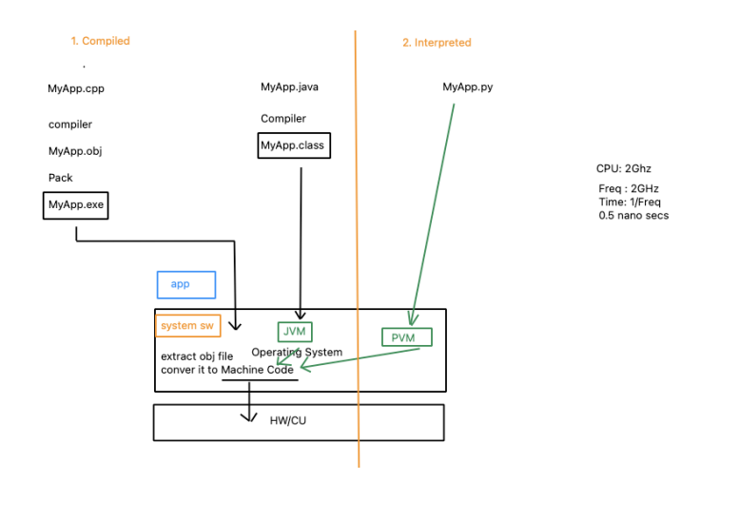Compiler vs Interpreter
* Database Introduction
* MVC Architecture
* 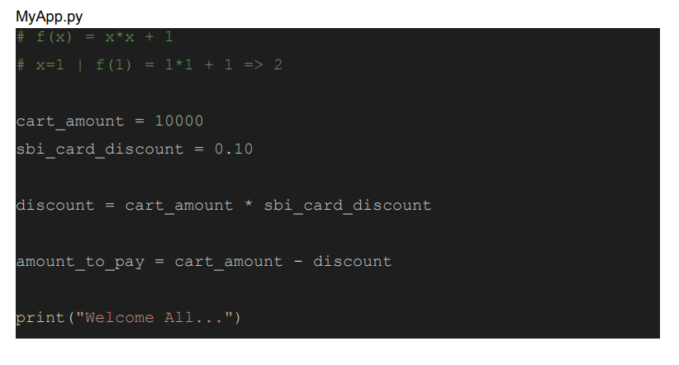Basic program

2 Day:-

* 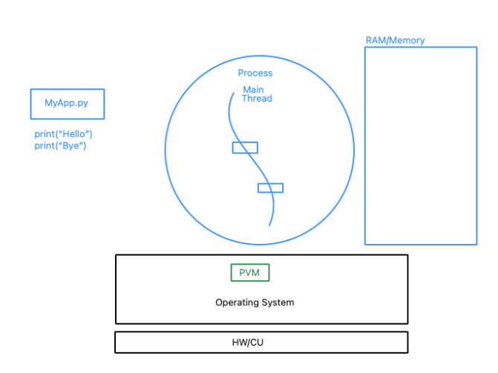What is a Process?
* 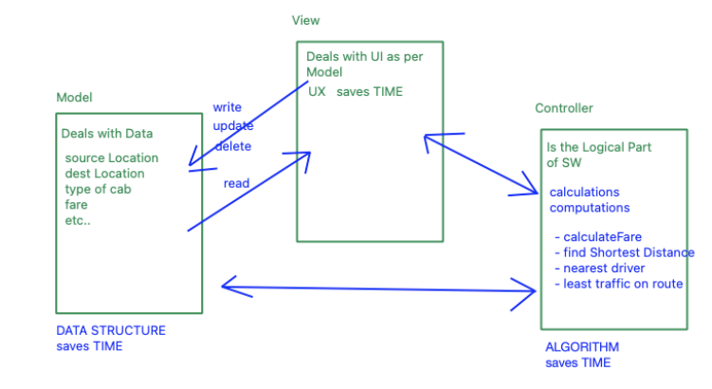MVC Architecture for software
* Storage Containers
* Single Value Container
* Multi Value Container
  + - Homogeneous
    - Heterogeneous
* 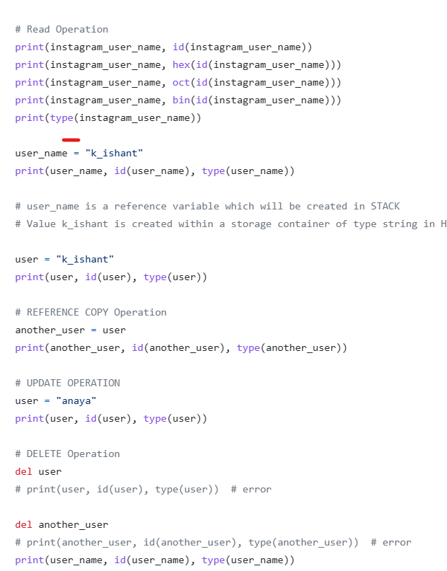Python Programs

Day 3:-

* HashTable (Hashing and HashCodes)

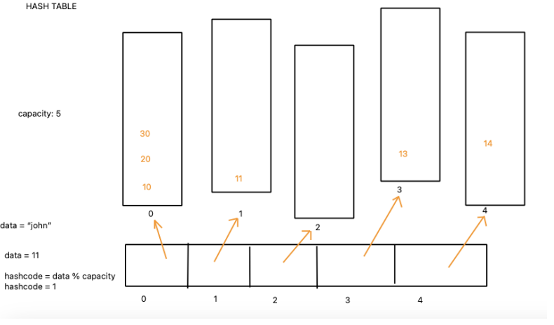

* Introduction to Multi Value Container
  + Tuple
  + List
  + Set
  + Dictionary
* Data Modeling Case Studies

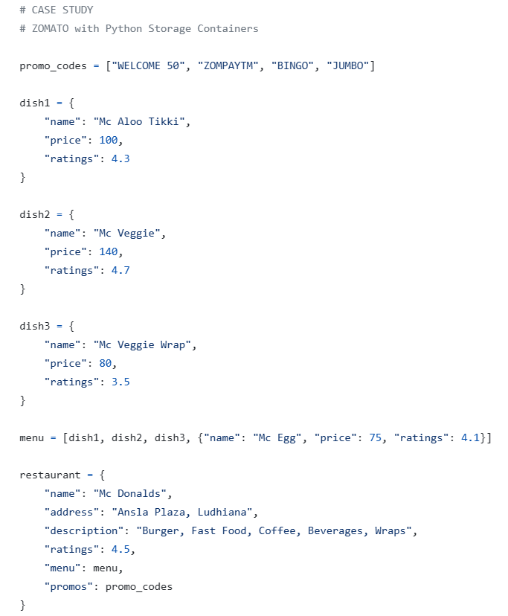

Day 4:-

